* 
* first load up bump up is not aligned properly (Critical)
* 
* under edit page “about me” the text isn’t the same as what you type. Enter become spacebar(Critical)
* 
* image takes very long time to load happen after the video upload fix. (Critical)

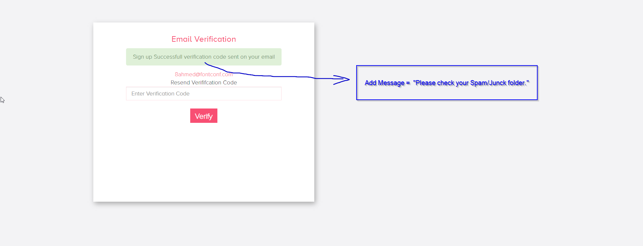

* When user sign up remind the user to check the junk mail for the verification code (Critical)
* Remove homepage and profile page animations (Critical)
* 
* Admin cannot delete complain in comments for the girl (Critical)
* when too many services is added the alignment is off (Critical)
* 
* when report has a lot of words it is all in one line. Can you wrap it? (Critical)
* 
* whenever map is clicked it is a random location can you set it the initial view is the whole of Australia? (Critical)
* 
* Admin notice cannot be sent twice. The second time user does not get the notification(Critical)
* 
* Each New “Go live” = 1 Free Bump Up automatically..., Not “Pause” and Resume”
* (Critical)



Can we add the following text for the pop up for the lock photo check box

“Locking photos will blur your photos and make customers pay to see your photos. You decide how much should the customer pay to see your photo. Doing so you can screen out insincere customers or just any random people from seeing photos that are private to you. Not locking will allow anyone to come into your profile to see your photo. You can lock only one photo or as many as you like.”

(Critical)

* 
* when we search Thebarton and set at 10km the address the girls are at become “null” (Critical)
* 
* the admin does not have full access to the girls edit page.
* Please add this language
* Korean
* thai
* Japanese
* hindi
* Vietnamese
* 
* Preferred not preffered (Spelling Correction) (Critical)
* Wechat id must not be number only (Other Contact is Alphabetic and Numeric)
* 
* the new message shouldn’t be a pop up just an alert on the top Right Corner. (Critical)
* 
* chatbox is too narrow cant see long message (Critical)